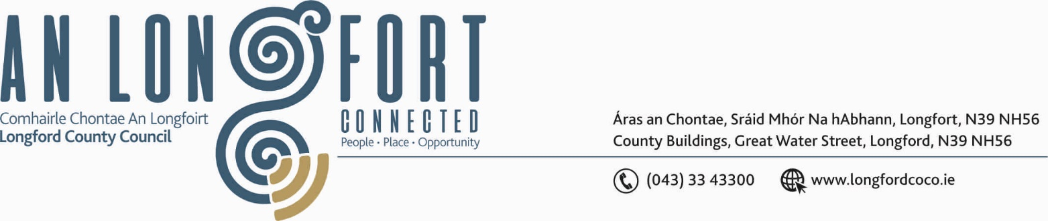

GRANARD MUNICIPAL DISTRICT

Please note Meeting will be held using Microsoft Teams

Corporate Affairs,
Aras an Chontae,
LONGFOIRT.

31st March 2020.

To: Each Member of Granard Municipal District.

Dear Member,

You are requested to attend Meeting of Granard Municipal District to be held, using Microsoft Teams, on Monday, 6th April 2020 at 3.30 p.m. to transact business, as set out on the Agenda hereunder.

Yours sincerely,
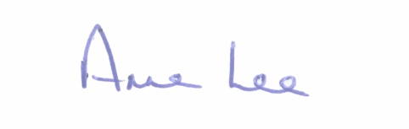

_______________
Anne Lee,
Meetings Administrator.

AGENDA

1. Confirmation of Minutes of Granard Municipal District Meetings held on the
the following dates –
- 28th January 2020.
- 13th February 2020
- copies enclosed

2. Matters arising from Minutes.

3. Declaration of Interest by Members.

4. Consideration of applications for funding under the 2020 Community Grant
Support Scheme - list to follow.



